

**Limerick Institute of Technology**

**Limerick Street art Map App**

**Software Report**

**Ruchi Devi**

**K00214120**

**Table of Contents**

Contents

Chapter 1. Introduction 3

Chapter 2. Objective 3

Chapter 3. Street Art 3

Chapter 4. Research 3

Chapter 5. Requirements 3

Chapter 6. Design 3

Introduction 3

Development Process 4

4.1.1 Agile 4

4.1.2 Project Management Software 4

4.2 Analysis & Requirements: 5

4.2.1 Functional Requirement 5

4.2.1 Non- Functional Requirements 5

4.2.2 User of the system 6

4.3 System Design 6

4.3.1 MySQL Database 6

4.3.3 Class Design 7

4.3.3 Architecture and Design Pattern 7

Chapter 7. Configuration 7

Chapter 8. Conclusion and Recommendations 8

Chapter 9. References 8

Chapter 10. Glossary 8

Chapter 11. Appendix 8

**Table OF Figures**

Figure 1Class diagram 7

# 

# Introduction

Limerick Art Maps is going to be an interactive map of Limerick City where people can click on street links and see and update new street art photos to the maps if it is not there or tag it to friends. This Street Art map is going to encourage and help people to find some Limerick street art. In this mobile App, each small section of the city and the different locations show some amazing artwork to explore.

This research was initiated by my interest in Street art maps. As I began my research into the project of Street art maps, the idea came to me to explain the street art as a form of visual art created in a public area, usually prohibited artwork performed outside the background of traditional art venues. Street art gained popularity during the graffiti art booms in the early 1980s, (Sadatiseyedmahalleh, 2015). Even today it continues to be used on a large scale inside city centres and towns in various techniques and categories to convey messages. Therefore, a different culture has appeared in many cities since the late 1990s. Also, street art placement of unassigned artwork has appeared in public places. Different people can understand it differently; some people can see it as a form of activities. On the other hand, some people may see it as an illogical response to display the street art in people places, simulating formal understanding of crime, law, culture and art. In addition, street art is inspired by the ancient inscriptions. Sometimes it has become a big issue because most of the people do not agree whether it is crime or art. Street artist have been blamed for vandalism, indignity and intention to ruin property, illegal intrusion and against social rules. In modern times the use and application of street art has changed. Nowadays street art is a promotional tool which is used to change the meaning of the landscape elements that dominate current cities, fostering social inclusion in the city.

Street art becomes popular in the 1970s and 1980s, but it has more of a following in the 21st century. Also, lots of people believe the explosion of technology such as mobile devices and Internet lead this form of art into success. Artist can use street art to speak to other kinds of people. They can give a useful message to the people through their arts in the street walls. Street art can completely vary in style and meaning. Just like other art forms it is used to express feelings, emotions or send an important message. Street artists use the inspiration from many sources such as web sites, digital media, famous classic art pieces and world problems. Street art is a form of art that has many other terms or variations. The term urban art, guerrilla art and post-graffiti are common and represent a more inspired form of street art rather than vandalism.

# Research

#### Reason to choose this topic

For my research I got the inspiration from the cork street art in the Facebook page. Also, my main motive to develop this kind of mobile app to promote the Limerick street art to the people and get more attention to it. Also, I saw some street arts in the Limerick city centre, which give me the aspiration to pick up this kind of subject where I can gain more knowledge and understand it from insider's perspective. The project which I choose will help me to get deeper understanding of the relationships between individuals’ art and a public space.

As walking in the Limerick city, I saw one art that, I can't decide if the eyeball ice cream cone or the hello kitty tattoo is favourite thing about this piece, but I would say it is definitely eye catching. The work of artists Smug it was commissioned for the Make a move Festival and has been captured by many people in the city. This is located on Castle Street Limerick. In this app I will give functionality to capture the picture and share it to the social network where GPS coordinator will give the exact location and the time when this picture clicked and shared include the location of the picture or the arts which created in the street wall. Also as the authorisation point of view some people may have objection to create the art in the local property where they can send the authentication to the local city council to approve the art which have been created in the local property. Many of the interesting and exciting features of street art follow from this consensual method of production these works are subject to alteration and destruction and hence street artists accept the resulting ephemerality of their work, these works are often illegal. Street artists have a strong incentive to remain anonymous to the public at large and to the relevant authorities in order to avoid getting caught. They neither have an implicit interest in being known within the street art community, recognized by the public at large and neither known nor recognized by police and other authorities who might legally act against them. In this respect being a street artist involves a delicate balancing act between remaining anonymous and unknown to authorities but established oneself within the street art community and public at large by having one's work recognized and associated with one's.

As Street art and graffiti stands today for highly productive branding tool that used by ad agencies and marketing executives in a bid to target the youthful ( (Maric, 2014). Such as huge branded companies like Coca –cola Sprite, Reebok all those industries are being asked to integrate street art into their packaging designs (Butss, 2014). Even though companies using the medium of walls for their marketing campaigns.

#### Purpose

The purpose of this research is that public art can contribute positive impacts on the quality of city environment, because such contribution can be useful in developing a better governance of city environment in which public art take a most important part to promote it.

#### Research Objective

The objective of the research is to explore the impact the public art on urban environment within the circumstances of Limerick city.

#### Target

The target auditions for this mobile app is the people who really interested about Street art and graffiti and who want to promote it to the other people.

In the last few years ago there have been several studies that have explored the problematic of connecting stories and maps in web or mobile applications. In (Nicola Maiellaro, 2014) Maiellaro and Nicola look at four case studies of geographical information systems (GIS) for cultural Art available on the web. They argue that in all the cases it was not easy to distinguish the categories and types (subcategories) of the Points of Interest (PoIs) because they have the same shape and confusing icons and colours. They maintain that there should be a unique shape and colour for each category and a unique icon for each type; icons should be intuitive so that their meaning is easily understood. They also say that there should be other ways to access the PoIs and not only by navigation and search. They propose a solution where the map has several interface elements: a menu on the left with several function icons; a sidebar on the right with a search box and a list of the categories and types that can be enabled/disabled; a pop up box that is displayed by clicking on a PoI and shows the multimedia content associated to it; a slide that filters the PoIs relative to the time they were built. Maiellaro preferred a solution implemented as a web application (Montenegro, 2016) instead that as a native app because it was cheaper, platform independent and not dependant on proprietary stores for distribution.

Propose an implementation of an “Augmented Cultural Heritage” where mobile devices are used to enrich the experience of places with audio testimonies. Their solution is applied to the area of the Montenegro, in Tuscany, in Italy and uses as audio from the “Anna Buonomini” archive; therefore the audio is not made on purpose for the app, but is what they call an “Intangible Cultural Heritage” so making it available to a wider audience. The implementation is a mobile app that uses GPS to retrieve the position of the users and notifies the users when they are approaching a place that has an audio associated to it. To give an impression of reality the volume of the audio increases when the users go nearer to the places; this behaviour is realised by putting a Bluetooth beacon in the places of interest; the Bluetooth of the mobile device detects the distance from the beacon based on the intensity of the signal. A solution that uses “inconsistent maps”, i.e. maps that are not in scale and emphasise some areas or buildings, is presented by Lu in ( (Lu, 2013). They claim that inconsistent maps are easier to understand because they highlight the element of interest to the users; however, on these kinds of maps it is difficult to locate the user position because they are not in scale. Lu implementation utilises inconsistent maps on which are featured “event points” and “line events”, that connect the points, and together they are used to tell a story. The user’s current position is displayed on the map by an algorithm that considers the coordinated given by the GPS on the device and the coordinates of the two nearest event points.

# Chapter2

In this chapter I will discuss about the technologies that required to create the application for which this report is about, mostly about Android development and its library required for this project.

#### Android

In terms of this project, Android refers to the mobile operating system that is development by the Google and it is based on the Linux Kernel. Its main user for the device touch screen for example smart phone and tablets, but it also can be used to make specialised user interface for televisions and watches.

In the year of 2013 Google play the million-store hit mark for the Android application published. Where more than 50 billion downloaded this apps.

# Technology That using

In the technical research I came a across many technologies, where my main research was to find an open source map API and the appropriate tech language for my mobile app. In my research where I found the different map API as example OpenStreetMap, Google map API under this API there are sub type of the API.

#### Open Street Map:

This is a free wiki world map, and open volunteer driven initiative to collaboratively a map of the world and release the map data under a free and open license. There is actually many different API around the OpenStreetMap in the ecosystem, but my main concern is to download the data in API or create the raw data on it. In the OpenSteetMap is provides read and write operations on the raw map data of the openstreetMap database. It is primarily for openStreetMap editing software and although any developers can create a new editor tool this is not a small undertaking and should be carried out with careful consultation with the OpenStreetMap community. Based on free OpenStreetMap data, it is possible to create beautiful accurate and fast maps with native vector rendering and live customizable styling directly on a mobile device. One advantage of using the Open street map API is the map tiles can be easily displayed in custom native mobile applications on Android or an ios or any other platforms. To work on it, developers can load the map tiles online from a tile server of a choice or implement offline maps in the app displaying the maps from download or bundled tile extracts ( (GmbH).

One most important reason to use the Map API is that I must decide which map is suitable for the integrating on the react native app on android and ios

I did my research on Integrating Google maps into React Native App on Android. In this post they clearly show the step by step integration of the Google Maps into React Native App. (mehdiyev).

#### Leaflet VS Open Layers maps API

Leaflet is same as an open source JavaScript library for mobile interactive maps. It is developed by Vladimir Agafonkin of Map Box with a team of dedicated contribution. In this library has a 30 KB of gzipped JS code also it has all the features which all the developers need for the online maps. On the other hand, there is an open Layers map API which has high performance feature packed library with all mapping. Leaflet and open Layers can be define as mapping API’s tools with some of the features offered by Leaflet are following. (community, 2019)

Tile layers, drag panning with inertia, Scroll wheel zooms

Also, Open Layers provides some features which are the following.

Tiles layers- It pull tiles from OSM, Bing Map Box other many source.

It is a very light weight than leaflet.

#### React Native:

The Technology I'm using in my project is React Native which can be work on the both mobile application android and the ios. React Native is a JavaScript framework for writing real natively. It’s based on Reactive Facebook java Script library for building user interfaces, but instead for targeting the browser its targets the mobile platforms. As we can said that now we can write the mobile application that looks and feel truly native. This all happened because of the java Script library, React Native is known for its speed and efficiency. It is best suited for app and web development. That’s help a lot in reducing the cost and time of application building. (Mehul, 2018)

However, it provides an easy and convenient environment for mobile while using the debugging tools. As we know there are different type of React Native tools which play a most important role in accelerating the speed of the app development. As Pete Hunt states that React is designed to encourage the reusability of components that developer can creates. React use the JavaScript, as we that it is a flexible and powerful programming language to develop the large scale of applications.

In the React each component works separately from one another, which allowing for minimal and efficient changes to the DOM. As Facebook developed one another feature for React is the use of JSX, an alternative to standard JavaScript syntax when creating components. JSX similar like HTML and HTML5, which making it's readable to software developers who are familiar with those coding languages.

As we know that React has been gaining the more popularity in software development because of its flexibility and reusability that makes it for the ideal to creating a newer software project.

Since 2015 React Native become more beneficial for developers or a team who are on a budget as the application can support both major platforms with the same code base. Kociecki writes that in his latest React Native project, the development time took 33% less than if they had been developing iOS and Android separately. Also, development of a React Native application does not require the native developers who have a higher salary on average.

#### Why Native React:

The fact of choosing to react native to develop mobile application is that it allows perform complex tasks in a simple code. This framework uses the UI library created by Facebook to make more straightforward code for implementing and executing React JS. Also, in the react native mobile app had reloaded feature. It allows us to operate on real time code changes and make corrections while the app is loading. The foundation level programming uses the same code for both OS. It's like deploying the same app to all types of the mobile operating system. Also, it makes easy to be recompiling the app. (Ratnottar, 2019).

#### **React js:**

React JS is a JavaScript library for building a fast and interactive user interface. Typically, it is used for web development, as we could say that it has changed the way that we think about the front-end development. React.js has grasped the interest of the open source community and it is here to stay. However, at its core React is **a** library framework for the programming language JavaScript, which is used in web development.

## Android studio:

Android studio is an intuitive feature rich and official integrated development environment (IDE) for the application development. This is a based on the Intellij IDEA, java integrated development environment for the software code editing and development tools. It is easier and more productive to use for any Android App creation than Eclipse (Clifton Craig, 205).

The main advantage of using the Android studio is that it has a technology platform with its own ecosystem of tools to support it. After the Android studio next most important tool would be in the Android ecosystem. The most important features of the Android studio is the following:

Navigation Editor

Android Cradle plugin updates

IntelliJ IDEA 2018.2.2 changes

## GPS Coordinators:

#### GPS

## GPS is Global positioning system which is based on satellite navigation system made up of approximately 24 satellites. GPS works in any weather conditions, in anywhere of the world. The Department of Defence in US originally put the satellites into orbit for military use, but they were made available for all civilian use in the 1980s.

## Global Navigation Satellite System

## Global Navigation Satellite system involve the signals from the US governmental GPS, the European Galileo, also Russian Glonass and the Chinese Compass, Indian IRNSS (Choudhary, 2019). At the present only GPS and Glonass are operating, but when using the side by side signals increased but they not yet proved their strength. The possibility gain when several satellites is that we could see more satellite at the once, and which give us better GDOP and better accuracy in turn result.

#### Tools & Component:

React Native component libraries can be a huge time saver as working on the react project. React is open source JavaScript library that helps in building user interfaces for the both web app and mobile apps. it includes n number of components that will use in while developing app.

# React Native Map view:

This is a one of the React Native component libraries that offers map components for Android and IOS is React native map view. In this component have a lot to do customize the map style that can be able to change map view position and tracking the region or location and make the points of interest clickable on Google maps. Also, we can enable zooming in to specified markers or coordinates. GPS system to fetch the location and give you nice street view, also it has location search functionality.

# Software Report

## Introduction

The focus of this chapter is to identify and explain the methodology used during the development of this mobile application. Also, it will outline the functionality that requirements of the project along with all the tools and technologies that were apply during the implementation phase. The context of the social sharing application being developed for this project is related to performance and acting. The project focus is to create social art sharing application for both secure and useable, so users do not worry about their privacy being misused and they can enjoy the interesting artwork sharing to the people.

During the research phase conversation proceeding regarding Android and iSO architecture and its security, and some article with studies carried out regarding Android application and it’s reviewed.

An important aspect of the research is connection security of the application and as well as usability of the application by introduction of API.

As we know that now a day’s mobile application development is growing in popularity every year, but with its popularity grows the higher demand for that product and higher demand means less time to do it. That means while development of the application or a system there might be changes to have a vulnerabilities that can be used against user. So here I have been discussing about the application should be reviewed as a security point of view before beginning the application.

## Development Process

### 4.1.1 Agile

To support in development of the application in agile methodology was adopted. The aim of developing within the agile methodology is to set iterations or sprints, usually a short period of time, in that an aspect of the application is implemented and ready for release at the end of the sprint. Developing the project in agile methodology it breaks the project into separate areas, for instance web service, the core of the reactive native application, which consisted of the graphical user interface and the input and output of data. The status of the project is reviewed weekly with in meeting a supervisor which helps in identifying the any issues that may have arises during the development in previous week. Because identifying them in early of the stage, that could be easy to fix them at this stage and avoid a major problem later in the development process. Also, agile incremental and iteration approach makes it ideal for project development where change of requirement might occur and agile is best suited to adapt to these changes. Big project with this functionality level requires ability to revise certain aspects of design requirements or it can implement during development process. This can be result of expectations becoming higher from the end users in relation to the flexible inclusion development of application. At starting of each week user stories were picked to develop during specific weekly sprint to develop and implement. Once implemented feature were shown to test user to test and receive feedback at the end. Suggestion made by test user were considered and implemented into application during the next print week.

### 4.1.2 Project Management Software

Mostly in industry, software packages such as TFS and JIRA are used to track the tasks that need to be undertaken in order to complete a sprint and after that release a new version of the software. Team foundation server is flexible tool when it comes to strategies around Team project creation. Because of it evolve three key concepts of any organization and utilize the software development in its day to day work. For instance, project, product and organization unit, in the TFS each of these areas is very important to planning the project set up. For instance, in your organization have a multiple project which have no interrelations when it comes to code sharing, it may be beneficial to create different team project collection.

## 4.2 Analysis & Requirements:

The analysis requirement is an important phase in the development process. The Analysis requirements determine the features and functionality that will be developed in order to successfully complete the application. During the process the main sources where mostly focused on in order to determine functionality requirements. One of them was to analysis and review functionality of other existing application on the internet and play store.

# 4.2.1 Functional Requirement

The functionality requirements describe the capability and main functionalities of the application. The main functionality of this app is to viewpoints of interest of the street art of limerick city, and see your position and navigate to the artwork, also view the photos, position and information. Send your photos with GPS location to see them publish to the map.

* Ability to add the new picture
* Ability to delete the picture
* Ability to create the user account
* Ability to disable the user account.
* Ability to take a picture

### 4.2.1 Non- Functional Requirements

* During the development where there is a functionality to describe the application on other hand there are few non-functional requirements were considered. Non-functional specify how certain system are being used operate.

### 4.2.2 User of the system

The user of the system is the people who are interesting to the using and sharing their interest to street art. In this app people can add the photos to the map and or just visit in this app to see the street arts. The home screen rotates through a few street arts images that probably available in the featured images. Clicking on the featured images leads to more details about the arts, also it will provide the more information on the location of the piece of art. As it is a social sharing app people can give stars than we come to know how many starts it has received. As you switch to a map view an update button to update the app and images a new tab and there would be a artists tab. Map view defaults to a map of Limerick city and its streets, with black pins representing the location of the arts works. Also, if you are tapping on the pin it will displays a thumbnail view of the art which will take a few minutes to load the images.

#### 4.2.1.2 Google Maps API

To use the Google maps in the Android application, a Google maps API was installed through the command line by entering the following commands and using npm to install react native leaflet.

Under the google map to change it to the open street map

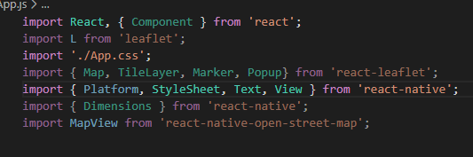

Figure OpentStreetmap

#### 4.2.1.3 Core Functionality

## 4.3 System Design

Software beginning point is system design. System process defines all architecture modules, interface, components and data, once done requirements gathered in process of requirement extract can be satisfied. During the process it was decided which components where required for system to be implemented and all requirements should be met. Component which were decided upon MySQL database, mobile application. Mobile application needs to be able to communication with the database, but mobile application does not able to direct communicate to the database. Mobile application needs to be depending on some component to retrieve data to the database. The logic of the application will be able to perform an action like add delete and update the database. This mobile application will be deployed on the android and iOS.

### 4.3.1 MySQL Database

Having extensive MySQL database meant implementation was vital task as it needed to be developed before any work could be started on the mobile application. Once all tables for all fields in them were defined it was just case of adding tables to newly created database in phpMyAdmin. Performing such detailed design of the MySQL database during the design phase meant that implementation of the database was relatively minor task. With all tables defined data types for all fields for all records also defined it was simply a case of creating the table using phpMyAdmin. Development of database locally gave advantage when developing it as it was easy to make any change to tables when developing mobile application. All important data had to be populated into a table before it counts have been exported to server. Using the phpMyAdmin one can export database to dump file with .sql extension with all table and data counted it. This functionality is mostly used to create back-ups for database, but you can set up database on different server. This sql dump file once executed then it will populate database with the same information as original one has. During the development database was first created and implementation of the MyphpAdmin and then using export method.

### 4.3.3 Database setup

To configure SQLite to interact with the mobile application a project needs to be added in the SQLite database console or in a repository. First thing we need to download the SQLite from here <https://www.sqlite.org/download.html> .

After completing the download, we need to write the simple interface code to execute the SQLite here is the code for the db. Below is the code for dependency of this project.

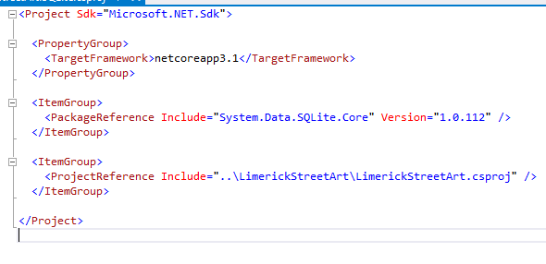

### ER Diagram

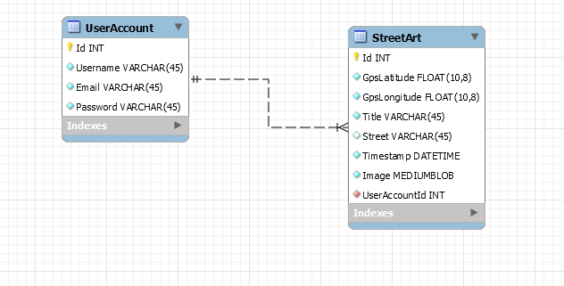

Figure Class diagram

### 4.3.3 Architecture and Design Pattern

#### 4.3.3.1 Architecture Design

This part of project is decided to explanation of the process that were curried out during design. There are few main components which play a major role. Android application that it is communicating with back end web application server and then backend which is sending and retrieving data from database.

#### 4.3.3.2 Configuration

First Step in the development process is to configure the react native, because before doing anything we need to install few things to set up the environment for React Native we need to install node js and npm .

Step1: Install create react native app.

After installing the Node js and NPM successfully on your computer you can now proceeding the installation of the create react native app blow is the code snipped for creation the native app.



Figure Create React native APP

After creating an app, we need to create the project, browse through required folder and create a new react native project as shown below.

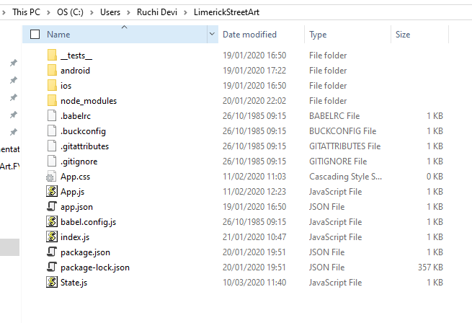

Figure Browse folder for the app

Step 4

Install react native CLI blow is the command for it.

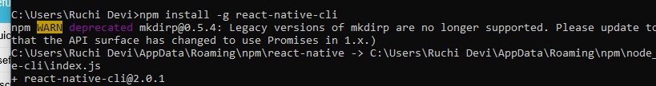

After installing everything for react native then we need to move on to install the lasted JDK and install the android SDK.

#### Configure your SDK

Open the android SDK manager on the window and make sure that you have the built tool version 3.5 or more. Below is the screenshot for android SDK setup.

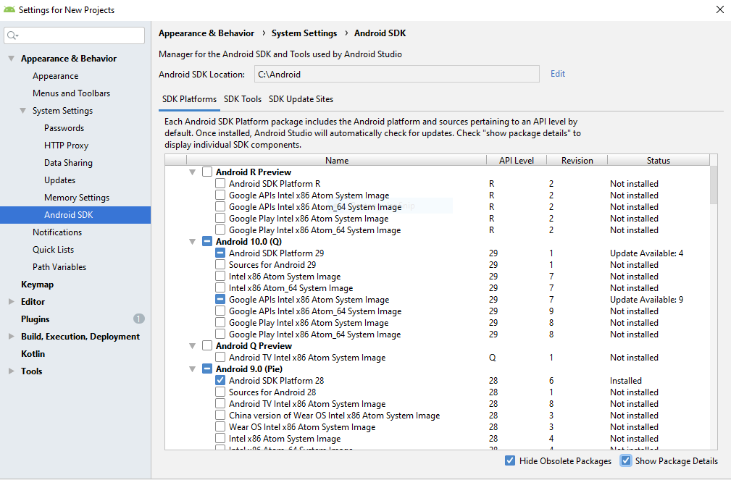

Second thing we need to create the android virtual device AVD and choose the device hardware that you need.

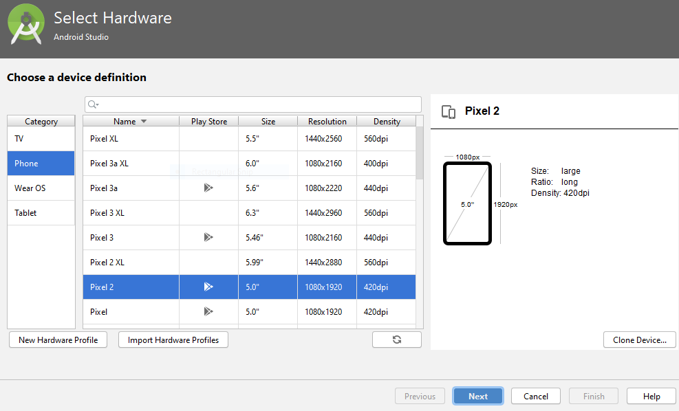

## Requirements implementation

Once all decision regarding design were made, it was time to working on implementation of the application. Before implementation process can begin decision regarding what development tools to use for each system component needed to be made. Integrated development environments (IDE)

## Development Environments

This application consists of web application, mobile application MySQL database and SQLite database. Each of these components require different tool for its development.

For development of mobile application Android Studio has been used. Android Studio is official IDE for Android development it is based on IntelliJ IDEA.

## Tools & Technologies Used

Platform specific tools to be installed for the application to run on an Android or iOS device. As Android was used for this project, Android tools were download and installed.

Firstly, java development kit (jdk) was downloaded and installed. After that download Android Studio which is an IDE for android app development. Which provided tools for building apps on every type of Android device and it can be downloaded from https:// developer.andrid.com/studio/index.html.

Once we installed Android Studio, and the important packages for the targeted API level were installed in Android Studio > Tools > SDK. Android development kit contains the tools that enable the creation, building and packaging of android applications. For this project Android 7.0 is the android version used.

#### Node. Js

Node is a runtime environment which allows you to write JavaScript on the server side. Node js often used to build developer tools, for example CLI that is the tool used for developing application. We can download node js from <https://nodejs.org/en/>.

#### Node Package manager (npm)

npm is the package manager for node. Which use for installing version package and resolving their different types of dependencies. It also uses to installed different modules which needed for the development of the Android application. It allows the installation sharing and packaging of node modules’ is automatically installed when node .js is downloaded.

#### Visual Studio Code

Visual Studio code was the chosen IDE to write the code for react native application. Also, it can be download from following link <https://code.visualstudio.com/>. It comes with built in support for JavaScript, typescript and node js, that required the development of the android application.

#### Visual Studio

Visual Studio was the chosen to write the backend code for the application. Where I’m using the .net core for this project. Visual Studio is an integrated development environment from Microsoft. It is used to develop computer program and web apps, web services also mobile apps. Below is the project structure and repository of this project.

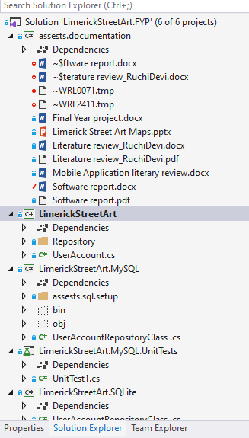

# 

# References

# Bibliography

GmbH, K. T. (n.d.). *Klokan Technologies GmbH* . Retrieved from Klokan Technologies GmbH : https://openmaptiles.org/docs/mobile/mobile/

mehdiyev, S. (n.d.). *Integration google map*. Retrieved from Integration google map: https://medium.com/@samil.mehdiyev/integrating-google-maps-into-react-native-app-on-android-40c984c0e4f2

Mehul, R. (2018, December 4). *Here’s a list of React Native tools that you can use for your next project*. Retrieved from Here’s a list of React Native tools that you can use for your next project: https://www.freecodecamp.org/news/heres-a-list-of-react-native-tools-that-you-can-use-for-your-next-project-db5abdf122b1/

Ratnottar, S. (2019, apr 30). *10 Reasons to Use React Native for Mobile App Development*. Retrieved 2019, from 10 Reasons to Use React Native for Mobile App Development: https://blog.bitsrc.io/10-reasons-to-use-react-native-for-mobile-app-development-4ceb06b0173a

Butss. (2014).

Choudhary, M. (2019, 11 20). *What are various GNSS systems*. Retrieved 1 16, 2020, from GEOSPATIAL WIRLD: https://www.geospatialworld.net/blogs/what-are-the-various-gnss-systems/

Clifton Craig, A. G. (205). *Learn Android Studio:Build Android Apps Quickly and Effectively.* Apress.

community, s. (2019, May 12). *stackshare*. Retrieved January 12, 2020, from stackshare: https://stackshare.io/stackups/leaflet-vs-openlayers

Lu, M. A. (2013, January 03). *Map-Based Storytelling Tool for Real-World Walking Tour*. Retrieved January 18, 2020, from Map-Based Storytelling Tool for Real-World Walking Tour: https://link.springer.com/chapter/10.1007/978-3-642-34203-5_24

Maric, B. (2014, july 29). Retrieved 1 2020, from https://www.widewalls.ch/the-history-of-street-art/

Montenegro, M. C. (2016). Digital Heritage. In *Digital Heritage* (p. 22).

Nicola Maiellaro, A. V. (2014). The Albanian Cultural Heritage on the Internet. 1.

# Glossary

# Appendix